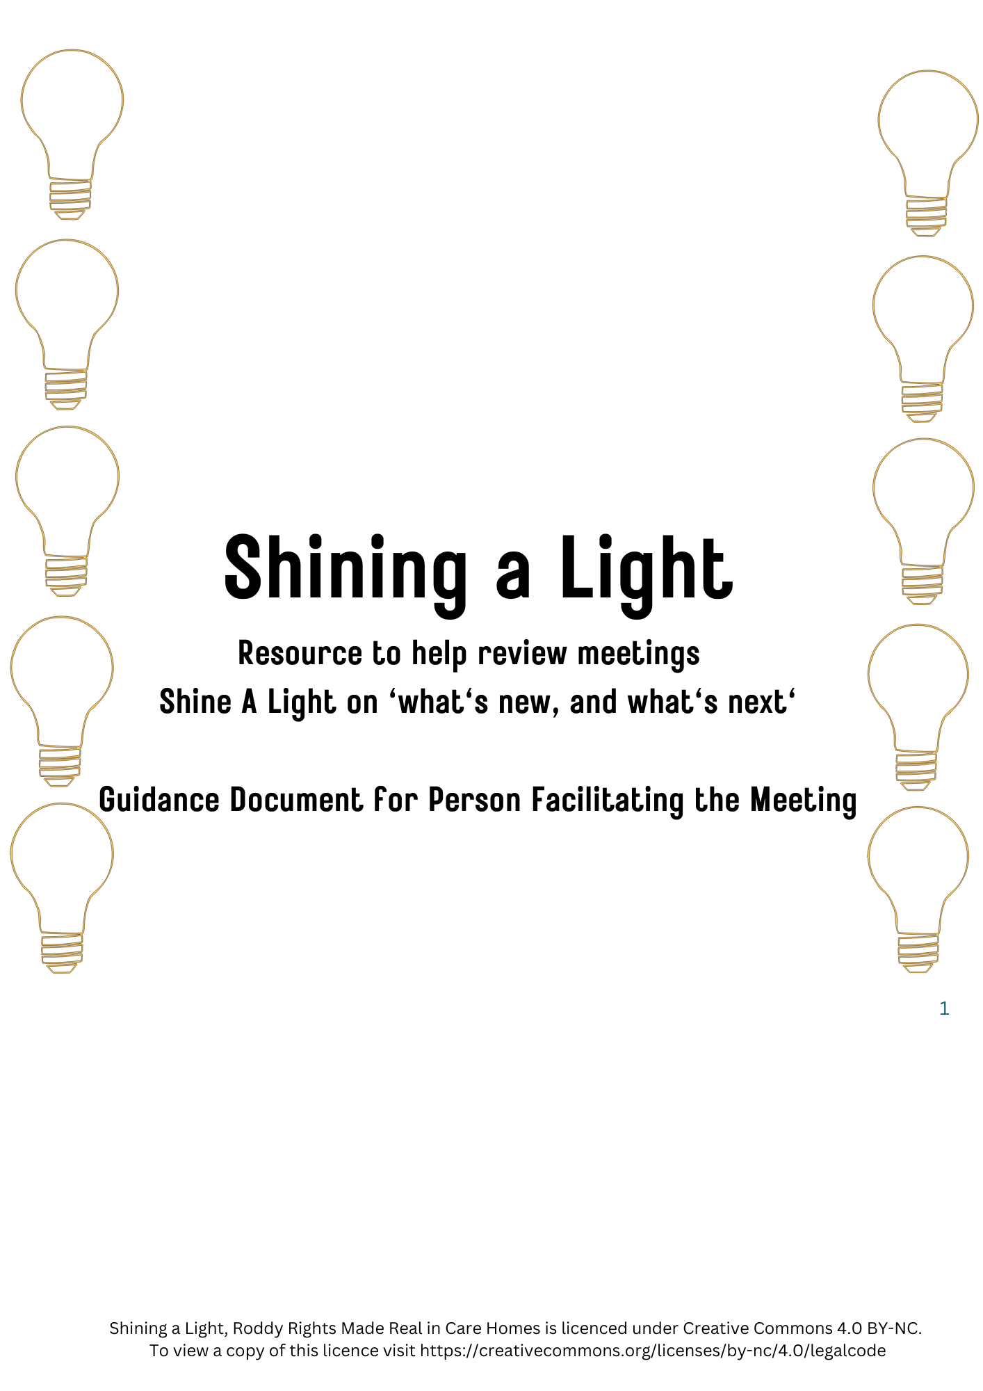

About Shining a Light

This resource has been developed to support review meetings to be engaging for everyone who is attending them. It encourages sharing of stories, celebrating things that have gone well, and makes space for people to share any hopes, concerns or questions they might have.

The resource has been inspired and informed by a collaboration between Laurel’s Lodge Care Home, Aberdeen and Jill Will, Robert Gordon University. This collaboration took place as part of Rights Made Real in Care Homes Phase 1, whereby the topic being explored was Anticipatory Care Planning. As part of this exploration, staff in Laurel’s Lodge and Jill Will identified the importance of review meetings in opening up valuable conversations around people value and hope for. They developed a process for review meetings which has now been developed into the Shining a Light resource.

Below is a suggested process for using the Shining a Light resource. You might want to tweak this so that it best fits with what will work well in your care service.
Before the Meeting
Have a print-out of the Shining a Light resource ready, as well as a copy of What’s New and What’s Next if you are using this to record key points of the conversation
You might want to think of a story that you would like to share about the resident who is at the heart of the meeting.
Check in with colleagues, as you would normally do, on anything they would like to be shared or asked at the review meeting

Beginning the Meeting
Lightbulb 1: Shining the Light on a Memorable Moment/ A Moment that Moved Me
Purpose: To begin the meeting with a focus on people at the review meeting connecting through sharing a story about the person (resident)
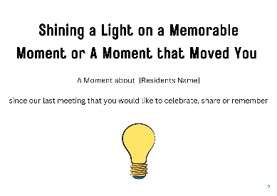
Process:
Invite people to introduce themselves if they don’t already know each other.
Share how long you expect the meeting will be, and check in if this is ok with those attending.
Place P.2 (see image above) of the Resource on a table so that everyone can read it.
As the person facilitating the meeting go first, and share your story about memorable moment/ moment that moved you from [person who is the focus of the meeting] the last 6 months that you would like to share, celebrate, remember.
Ask everyone in turn if they have a story they would like to share- mentioning that people are free not to share a story if they prefer.
Once everyone who wants to share has shared, you might like to check in with people if they would like to say anything in response to the stories they’ve heard

Lightbulb 2: A Day in the Life Of
Purpose: For staff and relatives to hear and learn from one another about ‘ a day in the life of [the person who is at the heart of the review meeting]
Process:
Place P.3 where people can read it.
Share what makes up ‘a day in the life of the person’ * - this could include for example: where in the home they like to spend their time, people they like to engage with, the types of activities they do (if relevant), things important to them at mealtimes
If the resident is present check if they would like to share this themselves
After you have shared about ‘a day in the life of’ you could ask some of the following questions in your own words or come up with other questions of your own
- What stood out for you in what you heard?
- Is there other information or insights you would like staff to know?
- Is there anything else that might help to make a good day for the person?

Lightbulb 3: Shining a Light on What We Would Value Talking About
Purpose: Create opportunities for everyone at the meeting to say out loud what they would like to talk about
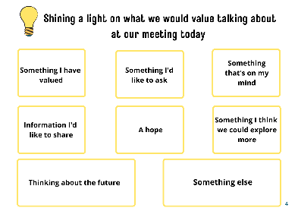

Process:
Place P.4 of the resource on the table for everyone to see.
Invite people (resident if present, relatives and staff) to think about what they would like to talk about at the meeting today, and ask if any of the prompts on the resource give them ideas for what they would like to focus on.
Ask people to share what they would like to talk about, this then becomes the agenda for the meeting.
Open up the discussion for people to talk about the topic that is important to them. You may want to outline again how much time people have for the meeting, so that people can decide which topics are most important to discuss.
Take brief notes about the meeting- with a particular focus on capturing anything that’s new e.g. new information, new questions, new hopes, new concerns etc. and also anything that has been agreed re what people would like to happen next.

Lightbulb 4: Sharing How We Feel at the End of the Meeting
Purpose: To gain a sense of how the meeting was for people.
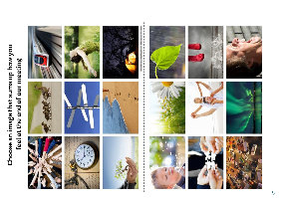
Process:
Place P.5 and P.5 where people can see the images.
Ask people to choose an image that sums up how they feel at the end of the meeting.
Go first and share the image you picked, and why you picked it.
Invite everyone in turn to share about their image. If someone says that they don’t wish to pick an image, ask them if there is anything they would like to share about how they are feeling at the end of the meeting.

After the Meeting
After the meeting, write up your notes from the meeting using the What’s New and What’s Next document- see What’s New and What’s Next document.

