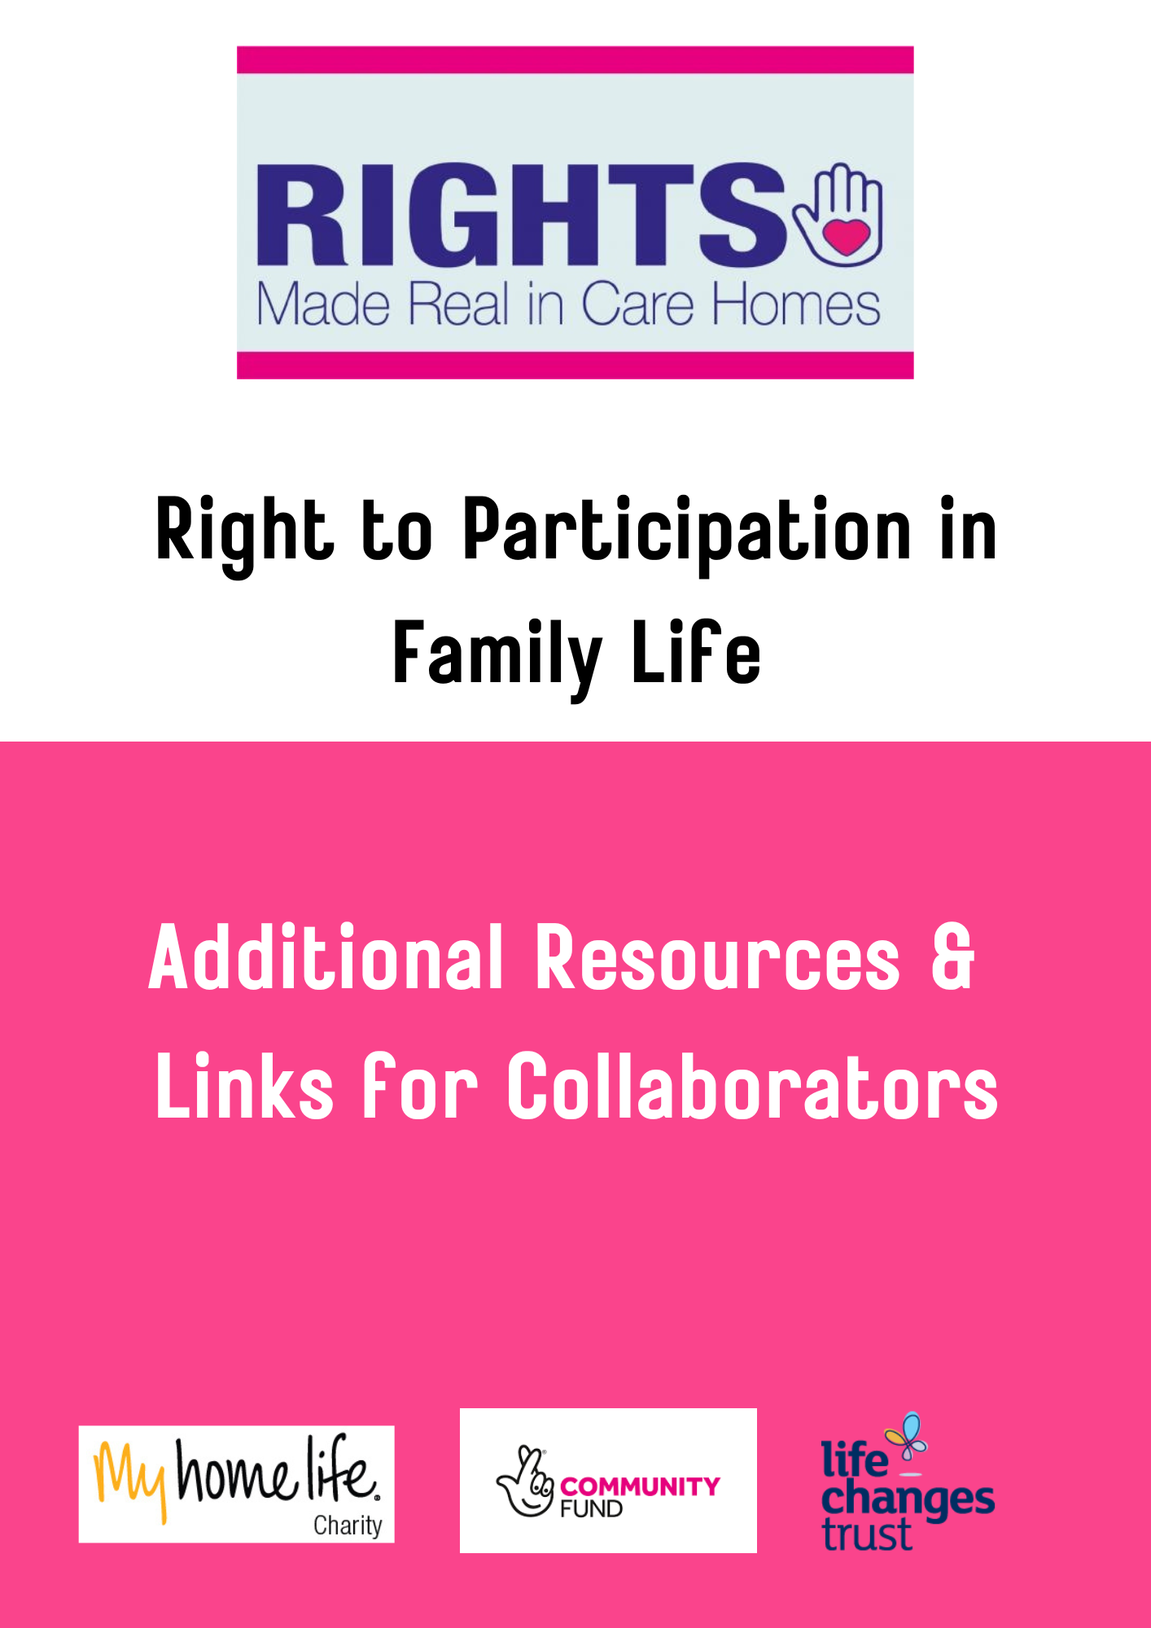

Resources
A Resource for Carers- The Treasure We Seek Treasure Hunt
https://www.heartsminds.org.uk/elderflowers/carersresources/

Shining a Light Resource for maximising engagement in Review Meetings, and exploring ‘what’s new and what’s next’ is available under the Personal Expression Resources Tab on www.rightsmadereal.org.ul.

Links for Collaborators
Exploring and Enhancing Connection
https://www.suzieferguson.com/

