e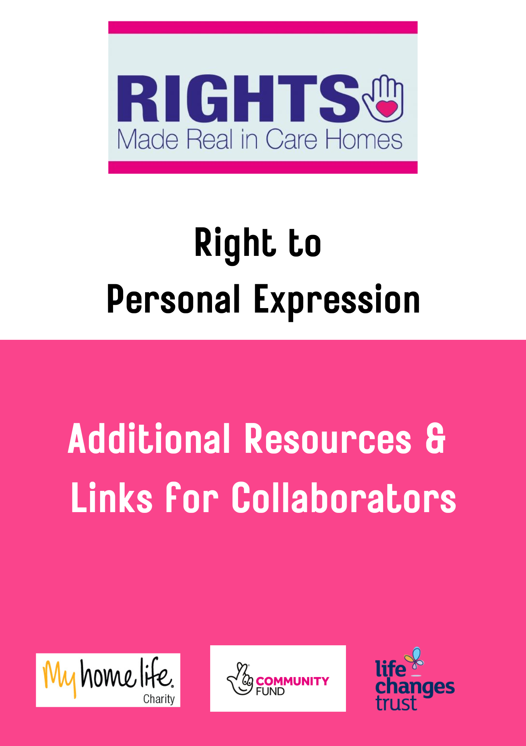

Resources
In addition to resources on the Resources- Personal Expression Resources page at www.rightsmadereal.org.uk, other resources connected with Personal Expression, developed with care homes, are available at http://myhomelife.uws.ac.uk/scotland/resources/

Links for Collaborators
Elderflowers - Hearts & Minds
http://www.heartsminds.org/

Magic Moments Activity Packs – Magic Me
https://magicme.co.uk/

Namaste Care Training
Lorna Reid- Prince & Princes Wales Hospice. Fiona Irvine Ayrshire Hospice

Personalised Music Moments- Dr Jane Bentley
https://artbeatmusic.org/

