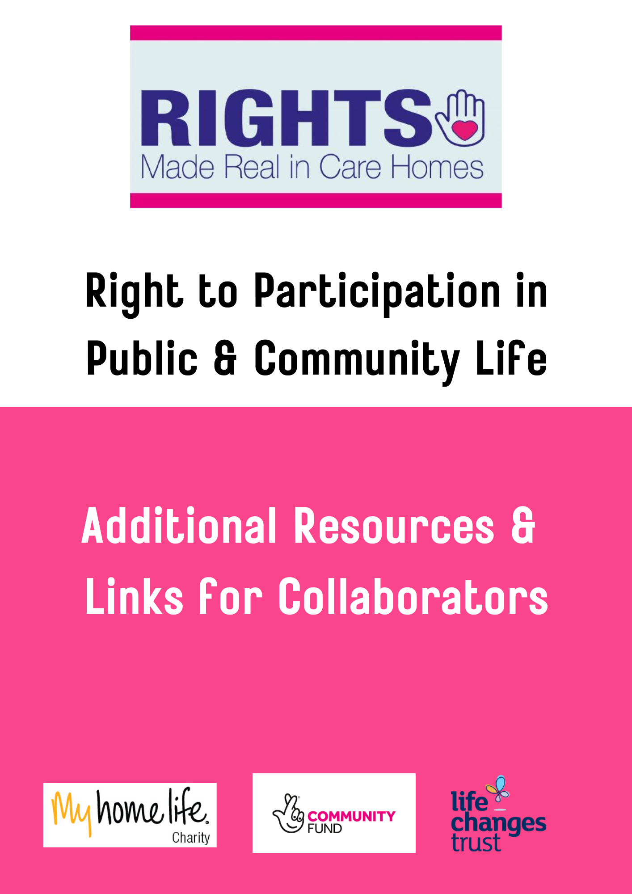Resources
A Report on the Summit of Care Home Residents Right to Vote will be shared in November 2022.

Links for Collaborators
Intergenerational Play & Storytelling
Phase 1
Generations Working Together- https://www.generationsworkingtogether.org/
Phase 2
https://dfel.org.uk/

Par-Tee Golf Bags
https://active.fife.scot/

Summit on Care Home Residents Right to Vote
About Dementia-
https://www.ageuk.org.uk/scotland/what-we-do/dementia/about-dementia/

